

School of Public Administration  
Bachelor of Science in Computing

**COMP491 Final Year Project  
Weekly Status Report**Academic Year 2018/19

|  |  |
| --- | --- |
| Pattern Recognition using Machine Learning | |
|  |  |
| Project number: | 20 |
| Student ID: | P-15-0792-1 |
| Student Name: | Zhiming Lin, Tony |
|  |  |
| Supervisor: | Dr. Yue Liu, June |
| Assessor: | Dr. Yang Xu |

Table of Contents

1 Preliminary Project Work Plan 2

2 First semester W4-W14 3

2.1 Week 4 3

2.2 Week 5 3

2.3 Week 6 4

2.4 Gantt Chart 5

2.5 Week 7 6

2.6 Week 8 (repeat up to Week 14) 6

3 Second semester W1-W13 8

3.1 Week 1 8

3.2 Week 2 (repeat up to Week 12) 8

3.3 Week 13 (Conclusion) 9

# Preliminary Project Work Plan

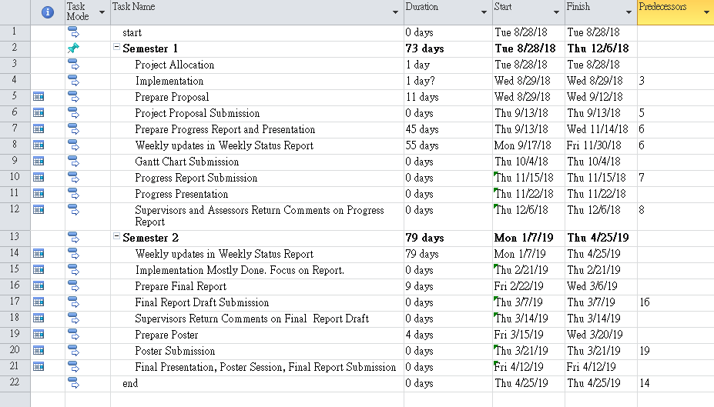

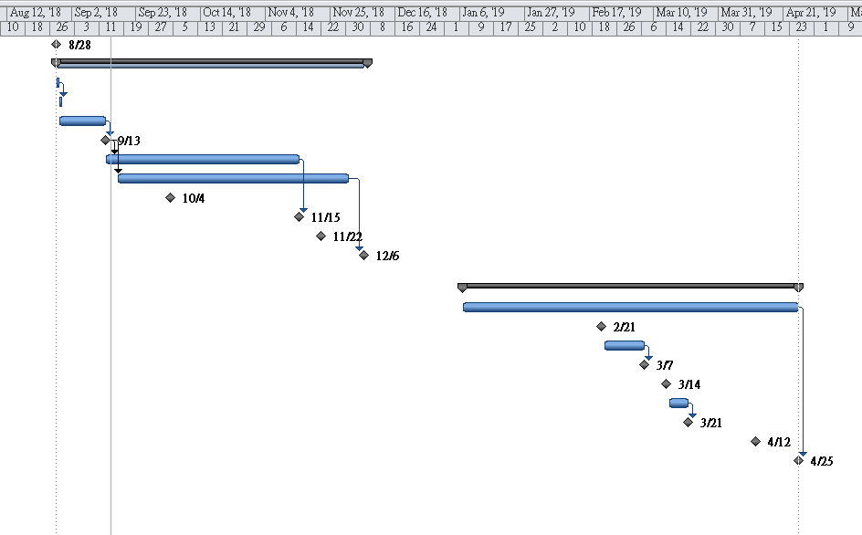

# First semester W4-W14

## Week 4

Report Date: 13/9/2018

### Tasks done this week

In this week, I have read several papers which are related to my project. Unlikely, there are only few papers which are about using traffic camera with deep learning to tackle traffic congestion.

### Plan for next week

Next week, I will search whether there is a suitable existing dataset.

## Week 5

Report Date: 20/9/2018

### Tasks done this week

I have read more papers, which are using traffic camera to analyze traffic camera to analyse traffic flow. I also find a dataset of HK camera, however, it would be better to use the the dataset from Macao directly.

### Plan for next week

Next week, I will try to web crawling images from DSAT. Also, maybe I should try install Ubuntu and TensorFlow in A216.

## Week 6

Report Date: dd/mm/yyyy

### Tasks done this week

List what tasks you’ve accomplished in this week.

### Plan for next week

List the tasks you plan to do in the next week. In case you’re behind schedule, describe what you will do to catch up.

## Gantt Chart

This section shows the first version of the Gantt chart, as submitted in Week 6. It includes detail schedule for the project. The Gantt chart sets up the overall schedule for the whole project. Therefore, from Week 7 of the first semester onwards, you also need to check your progress against the Gantt chart.

You may revise the schedule in the Gantt chart during the course of the project. This is necessary, for example, in case of risk mitigation. You must include the updated Gantt chart in the Weekly Status Report in a section like this one. Explain the reasons for schedule revision. You should also adopt a sound method of version control to avoid potential confusion regarding which version is currently being used.

Modified Date: dd/mm/yyyy

Include Gantt Chart below

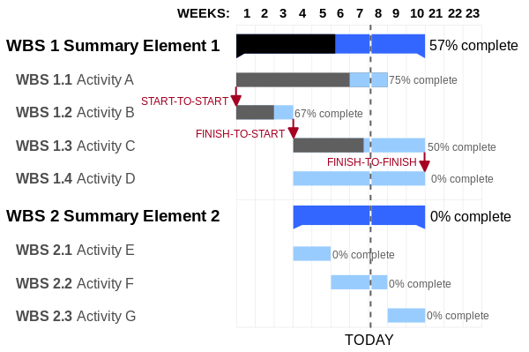

## Week 7

Report Date: dd/mm/yyyy

### Tasks done this week

List what tasks you’ve accomplished in this week.

### Progress check against Gantt chart

Use the Gantt chart to evaluate your progress.



### Plan for next week

List the tasks you plan to do in the next week. In case you’re behind schedule, describe what you will do to catch up.

## Week 8 (repeat up to Week 14)

Report Date: dd/mm/yyyy

### Tasks done this week

List what tasks you’ve accomplished in this week.

### Progress check against Gantt chart

Use the Gantt chart to evaluate your progress.



### Plan for next week

List the tasks you plan to do in the next week. In case you’re behind schedule, describe what you will do to catch up.

# Second semester W1-W13

## Week 1

Report Date: dd/mm/yyyy

### Tasks done this week

List what tasks you’ve accomplished in this week.

### Progress check against Gantt chart

Use the Gantt chart to evaluate your progress.



### Plan for next week

List the tasks you plan to do in the next week. In case you’re behind schedule, describe what you will do to catch up.

## Week 2 (repeat up to Week 12)

Report Date: dd/mm/yyyy

### Tasks done this week

List what tasks you’ve accomplished in this week.

### Progress check against Gantt chart

Use the Gantt chart to evaluate your progress.



### Plan for next week

List the tasks you plan to do in the next week. In case you’re behind schedule, describe what you will do to catch up.

## Week 13 (Conclusion)

Report Date: dd/mm/yyyy

### Tasks done this week

List what tasks you’ve accomplished in this week.

### Progress check against Gantt chart

Use the Gantt chart to evaluate your progress.

